My Home working set up during my prof doc and in the current climate
Fortunately as my research has been expanding along with me being full time in October of 2019 moved home, the main reason was so that I could have a room that would be a dedicated study to allow for me to expand filecabinets for ever expanding research papers and references. In addition having a stand alone desk that allowed for an additional monitor screen which allows for larger split screen views across now 2 screens.
The new home also has the added benefit of being in a remote area of the town where I live.

Having had some experience over the last 2 years of working from home I think these points may help
I found that it can sometimes be hard to detach yourself from work when I is being dne in the home, This is where a certain amount of self disciplne is needed, for if not then you will burnout as never really being fully engaged with work and equally not fully engaged with your out of work leisure time.
Set hours- this is easier said than done and I have found over the years that it works best for me to say this week I am going to do 20 hours now this can be spread over 2 days or 6 days. It all depends on individual circumstances, and to ensure I stay on task I tally up and at the end of the week if I am short then these hours carry over to the following week

Keeping a diary
Helps with planning and reflective practice

A separate room or area that is just for work
I use the spare room and have a monitor and laptop and split screens to help with the volume of work. A window with natural light helps.

ME time – this is by far the best bit of advise I can give, every day even if only for an hour you need to have that me time, I find a bike ride, walk or even a jog helps release those happy hormones and again it not at a set time of day. Sometimes I do first thing at 6.00am or later in the day say 4 in the afternoon.
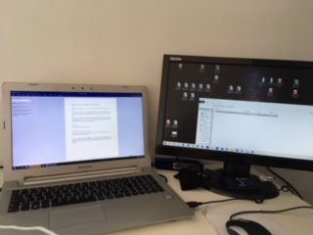my work station

What I have also found useful is having a good system of storing all those journals
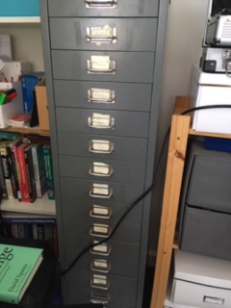 file cabinet for journals for each area has its own draw.

