*There are a few steps to perform before you can download data from your unit. This document is to help guide you through the initial process until you become accustomed to use*

Log in

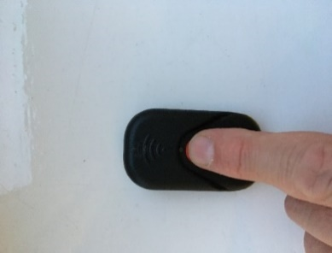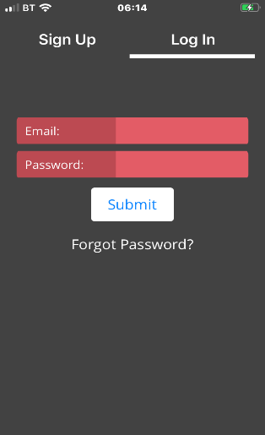

Turn your unit on (3-5 second long press until unit lights RED

Home screen

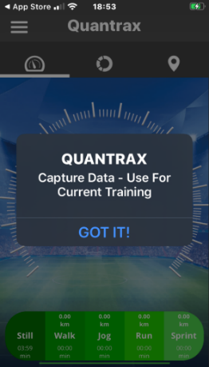

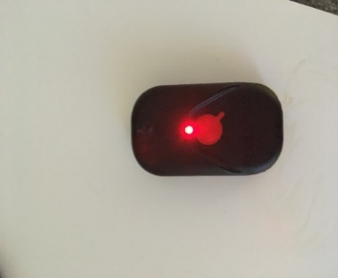

After turning on the colour will change to an amber-orange colour, this indicates ready to download your data

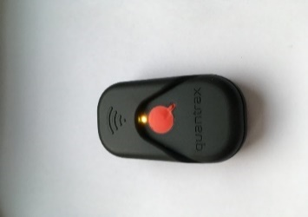

*If your unit flashes fast red as soon as turned on, indicates low power. In this case charge your unit before you carry on*

With IOS it is important that you turn **off** the phones **WIFI assist** feature before you start,

Then turn on your phones wifi if not already on

Step 2. Ensure your WIFI is on

Step 1. Turn off WIFI assist

1.

Go into setting and select mobile data

4.

Slide your screen up

and check your wifi on here

3.

slide the tab to turn off

2.

once in mobile data you then need to scroll down and turn off wifi assist (usually at the bottom)

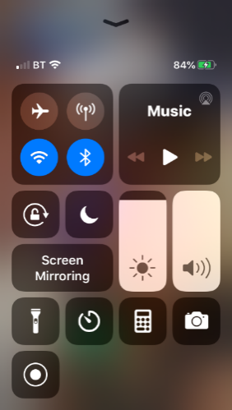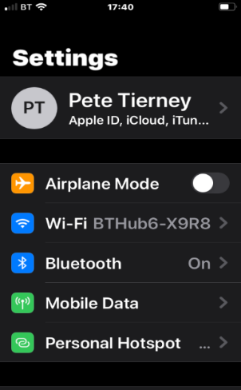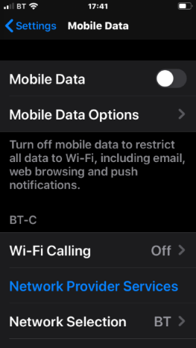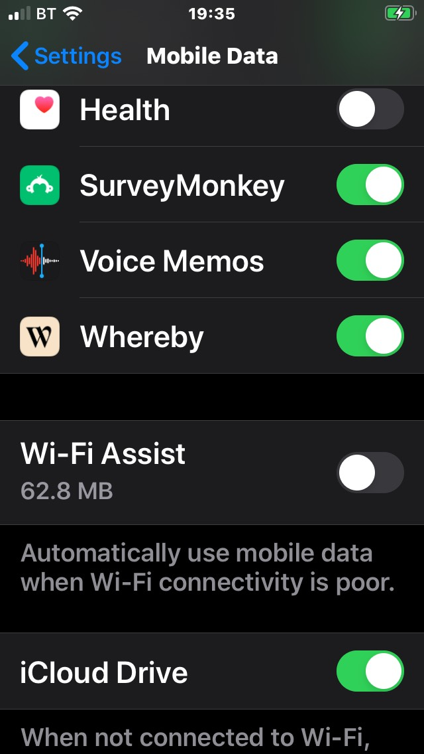

With IOS it is important that you turn **OFF** the phones mobile data **before** you start, this is because you will be using WIFI to download your session.

Step 3. Turn off Mobile DATA. Follow either of the options below

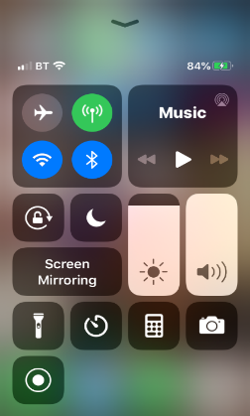

Go into settings and follow these steps below

Slide tab to off position

1

2

Turn off mobile data here

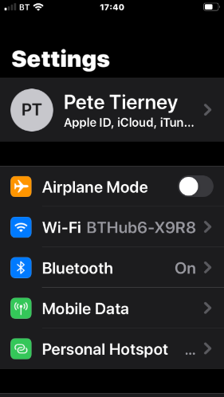

3

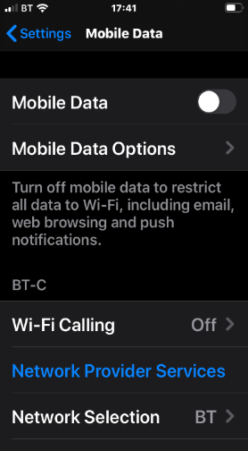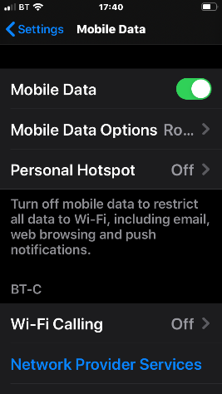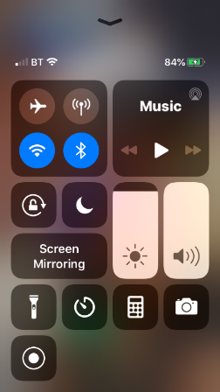

Slide screen up

You are now ready to capture the data from your Quantrax GPS unit

**Select menu On the screen** **Next select capture data** **Next press**

**START DOWNLOAD Message is displayed**

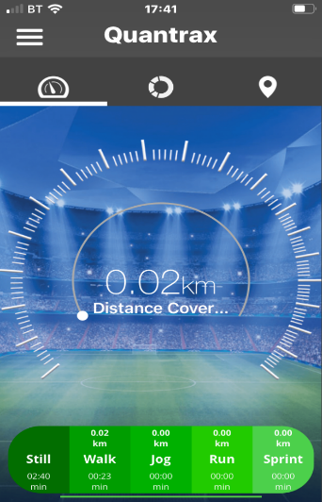

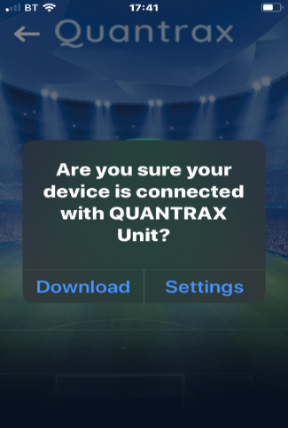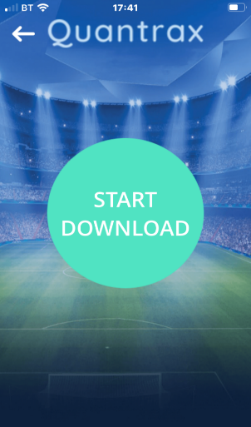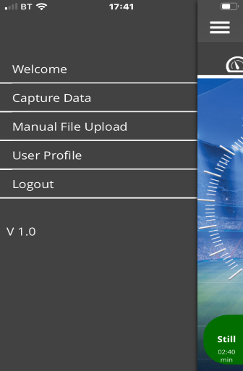

You need to go into settings

Follow these steps to ensure you are connected to your GPS units wifi Once you have connected you can then go back into the Quantrax app

4

*If this is the first time use, you may be asked for a password. The default password for your unit is:* ***12345678***

1. select settings

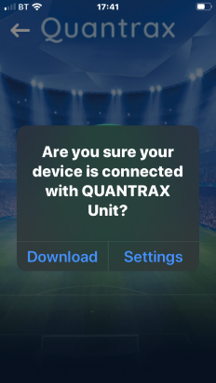

2. Select the

Wifi tab

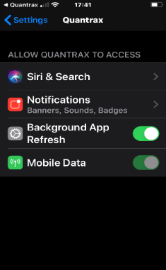

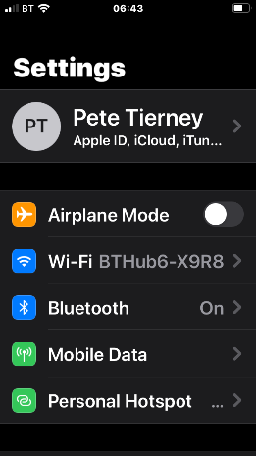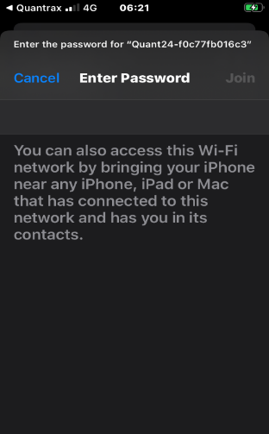

3. Select your

units Wifi

*The code is on the back of your unit*

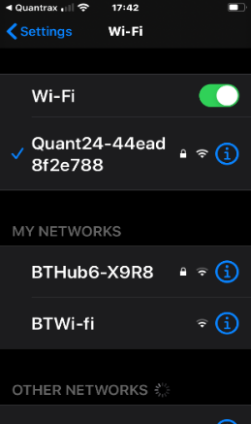

6

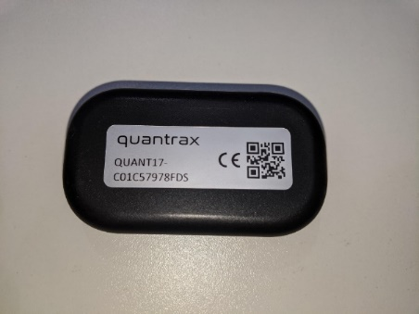

*Having selected settings you will be navigated to the screen displayed in step 1 above (1.)*

Go back into the App and press Download

The download is dependent on the length of session the bar below displays the progress

Once completed you now need to connect to your mobile data or other wifi source

**DO NOT**

**click on OK yet**

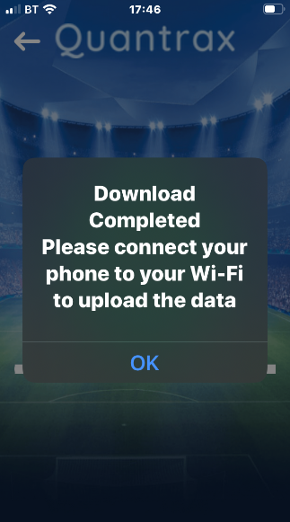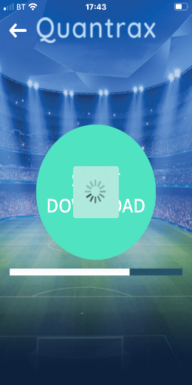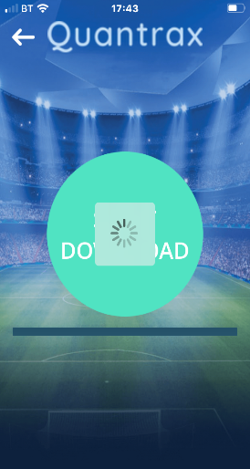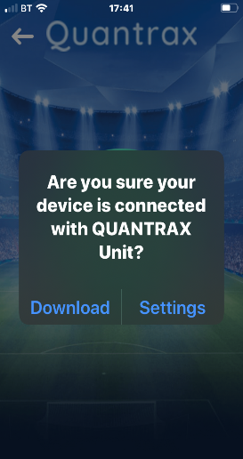

When it comes to uploading your data quantrax is able to perform anywhere.

You can use Wifi or Mobile data to upload and view your session by just following the below instructions

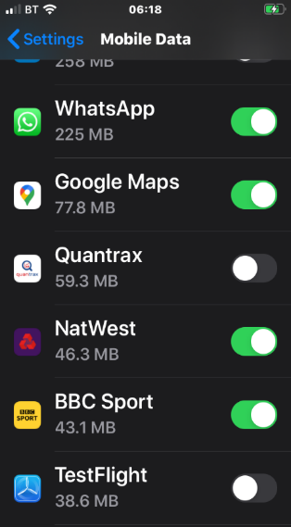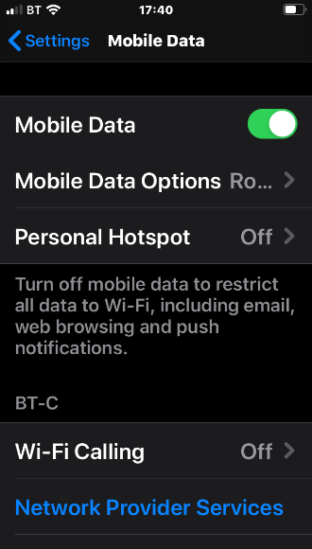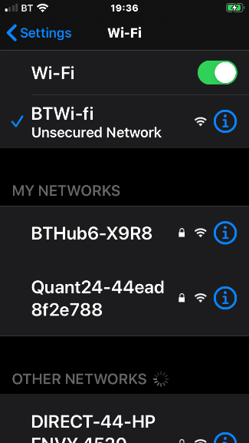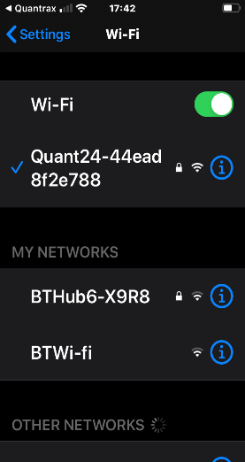

Make sure that you Allow access to the Quantrax App, Scroll down your apps

when you get to Quantrax if it is not on then slide the tab to on

**Or** turn your mobile data back on

You now need to select a local wifi to be able to upload your data

Go back into your phones settings you will see the Quantrax gps units wifi is still connected

Go back into the APP and click OK

You will now be able to see the summary of your session

Once your session has been processed you will receive a message

Complete the session description and then select upload

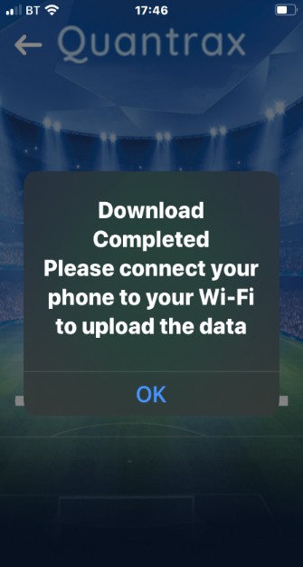

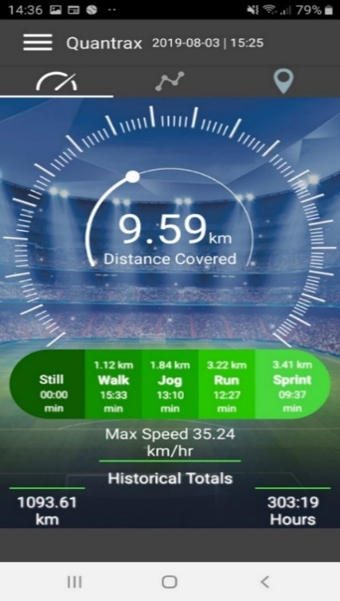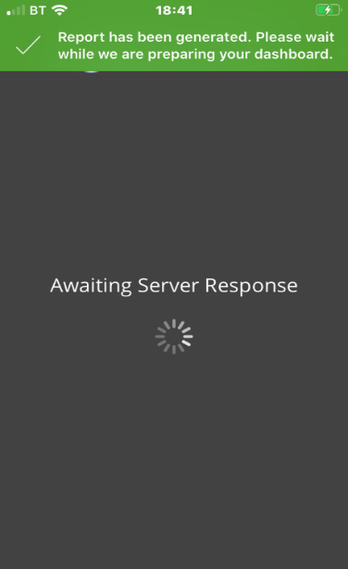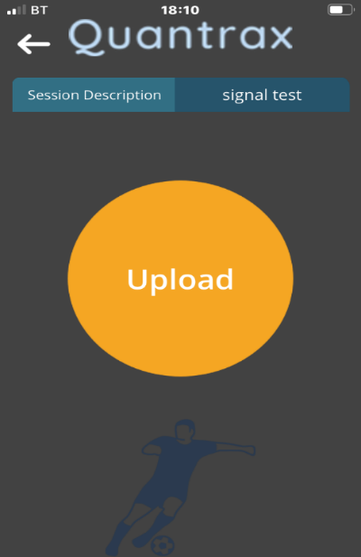

For further help see the trouble shooting guide or email [supprot@quantrax.co.uk](mailto:supprot@quantrax.co.uk) or [Contact@quantrax.co.uk](mailto:Contact@quantrax.co.uk) visit our website [www.quantrax.co.uk](http://www.quantrax.co.uk)