V1
Single user app
Welcome/dashboard
Capture data
Log out/login
Summary display session, day, week , month, year
User profile
Name ( does not have to be full name)
Email (recognised email address)
Age ( compulsory field this will tie in with speed zones for V2)
Weight ( in KG) this may be required for impacts algorithm?
Sport ( create a drop down list) – rugby, soccer/football,hockey,fitness, netball
Level pro, semi pro, amateur, beginner
V 2
When input age then system automatically selects default speed zones as per document
AGE DESCRIPTION SPEED ZONES for V2 ( an example)
Adult elite 18+ years
zone | Km/h | description
1 | 1-7km/hr | Walk
2 | 7-12km/hr | Jog
3 | 12-17.7km/hr | Running
4 | 17.5km/hr+ | HSR (high speed running)
5 | 25km/hr+ | Sprinting

Adult Leisure 18+ years
zone | Km/h | description
1 | 1-6.5km/hr | Walk
2 | 6.5-10.5km/hr | Jog
3 | 10.5-15.5km/hr | Running
4 | 14km/hr+ | HSR (high speed running)
5 | 16.5km/hr+ | Sprinting

YOUTH young adult (14-18) years
zone | Km/h | description
1 | 1-6km/hr | Walk
2 | 6-10km/hr | Jog
3 | 10-14km/hr | Running
4 | 13km/hr | HSR (high speed running)
5 | 14km/hr+ | Sprinting

CHILD and youth (9-14) years
zone | Km/h | description
1 | 1-5km/hr | Walk
2 | 5-9km/hr | Jog
3 | 9-12km/hr | Running
4 | 12km/hr+ | Sprinting

V1 Team system
Need to be able to download-upload multiple units
Display Team session with all players displayed in sliding scale all metrics
web browser –
Calendar view in web browser to select sessions for download/view
Select single player, groups and whole squad, able to crop and split sessions as before, delete players, sessions,

V2 team system
Additional metrics for team system to include
- HSR Distance -This is all distance above 18km/hr (for pro adults but scalable along with level)
- sprint Distance – This is all distance above 24km/hr (for pro adults but scalable along with level)
- Directional lines on map displaying max sprints
- Number of Acc decels (>2.5m/s)
- Average Speed (m/min) – total distance covered divided by total time (min) training.
- Weekly Distance to Date (cumulative daily for each week) – resets start of next week.
- Comparison report/highlight for compared to historical best for each session that would help track (dropping or improving).

TAB Features for changing of speed zones and descriptors

Customising speed zones within the web browser platform
On the menu tabs select speed zones
a pop up will appear here you can select customise zones to create your own zones
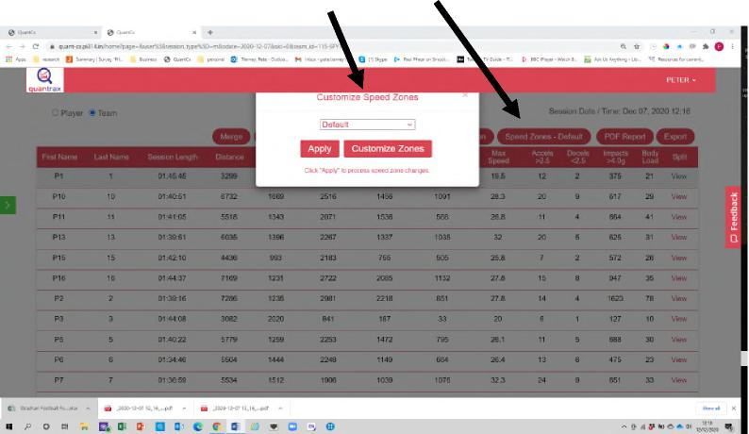
Once selected you will be taken to the below screen, here all your created speed zones are stored and where you can create new. To create a new zone select Add New zone
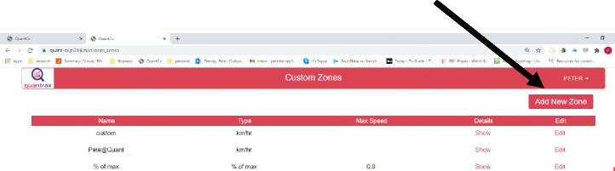
You will then be taken to the below screen, this is where you can select speed either Km/hr, m/s, or % of max speed The 5 of max speed will be based on each individuals max speed and the system will automatically update this as sessions progress. Changes made will also change retrospectively historical data. You can create as many zones as you want here and also name them what you want

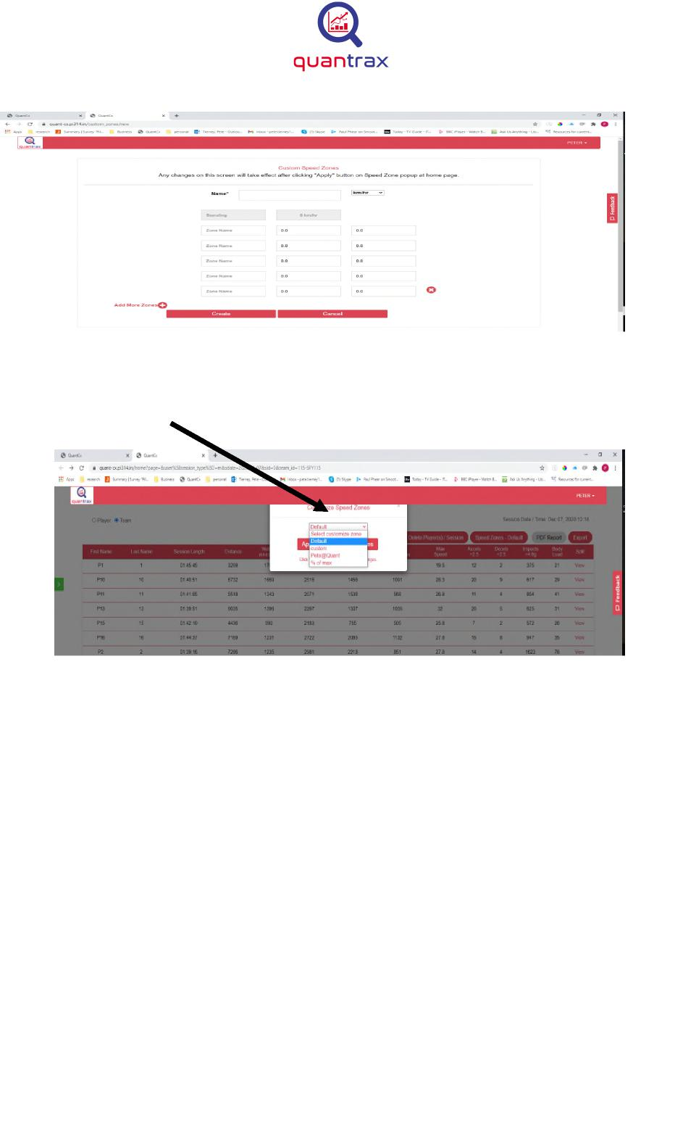
Once completed simply select the create tab and this will now be ready to apply. Now when you press on the customise tab as shown below you can select your speed zone from your drop down menu
The below screen shot illustrates the naming of tabs and setting of speeds in this feature

Once applied the named tabs and speeds for these named tabs become the newly generated zones and the data automatically then populates these based on the parameters set in the customising of the zones feature, with no limit on the number of tabs or sensitivity of speeds in that these can be in any number of 0.5 Km/hr increments.

WIFI
Communication of data exchange between Phone & device:
1. Phone would request the size of the recording ( How many indexed items in the list.
Command "s": 0x73, 0x02 (Phone -> Wifi module)
response: WiFi module - > Phone
0x73, 0x04 , "upper byte", "low byte" - total number of records up to 64k (unsigned int16)

2. Phone request a record base on record number:

(Phone -> Wifi module)
Command "g": 0x67, 0x04, , "upper byte", "low byte" - a record number

response: WiFi module - > Phone
0x73, 0x28 , +38 bytes based on the structure :
Index | Time Stamp (ms) | GPS Lat | GPS Long | Accelerometer | Gyroscope | Compass | Heart rate
2bytes | 8bytes | 4 bytes | 4 bytes | 3 x 2 Bytes | 3 x 2 Bytes | 3 x 2 Bytes | 2bytes

3. Update complete:
Command "e": 0x65, 0x02 (Phone -> Wifi module)
response: WiFi module - > Phone
0x65, 0x02 _ acknowledgement of successful upload completion.

This data then ready to upload to cloud based analytics platform for processing and data insights.

