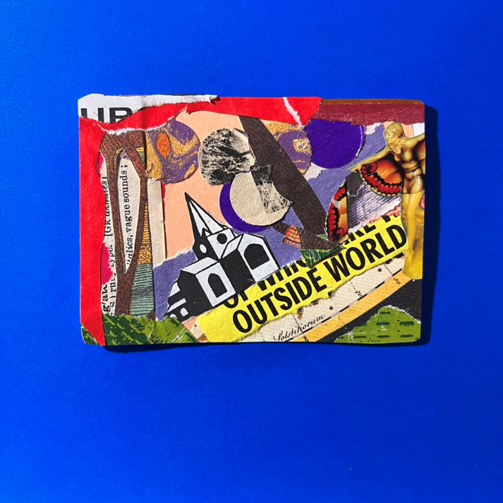

What comes first the data or the story? The story or the data?
Whilst this exhibition asks us what does data look like as a story?
Post qualitative inquiry asks us to revise what we even consider as data.
My name is Dr Peter Blundell and my contribution to this exhibition is an assemblage of items, some of which you can see or hear in the exhibition venue, others you can see and hear online.
The items intra connect in different ways.
Rather than a set of research questions my work is intuitively created with no boundaries and direction of where it might go.
It is experimental, intuitive, evocative, and meaningful to me. I hope it might be meaningful to you.
I am interested in how others experience this work. I would be interested to hear from you about how you connect to it or disconnect from it.
This is my first attempt as a post qualitative assemblage.
It began with a collage. I am a posthuman collage artist – in this sense I aim to decentre humans in this inquiry, decentre logical and rationale thinking. I invite you to think the unthought. Whatever that means to you.
The collage became inspiration for a short fictional story called Death of Small Church; you can listen to this in the exhibition. Inspired by the ghost and the church in the collage it considers community, spirituality and past-futures/future-past.
A posthuman reading of the assemblage is represented in the small research diary. A more in-depth reading is being developed into an article for publication which includes a more personal reflection on my relationship with this assemblage and its meanings.
The ghost in the collage and fictional story is a literalisation of hauntology: a being trapped in the residue of a future that never arrived.
The ghost is not a traditional human subject. She has no biography, no name, no memory of origin, and no future-oriented narrative.
The church is not a passive backdrop; it acts.
This is an example of Bennett’s thing-power - the capacity of nonhuman material forms to affect, disturb, and participate in agency. The church haunts the ghost as much as she haunts it. They exist in a reciprocal assemblage of stone, memory, ritual, and spectral presence.
The process of collage is, for me, something of a ritualised presence (Duckworth, 2026), it is an intuitive, yet familiar, process that helps me to be open to my experiences, it is something very grounded in the now. So, it was surprising to me how this research process unfolded into something that not only helped me explore the ‘now’ but was also so unequivocally linked to my past and my future.
The church reminded me of my own upbringing in a small rural community, a village life centred around the church. The church was a key part of my upbringing and my ancestry.
In writing this, the church has come to symbolise the heart of something for me, maybe something that is lost or gone forever. My childhood was filled with family, people and community. This appears to have waned in later life.
Thanks for taking an interest in this assemblage.
Dr Peter Blundell
p.j.blundell@ljmu.ac.uk
References
Duckworth, H. (2026). Holly Duckworth in post qualitative inquiry with author, January 12th, 2026.

