Statistical Analysis Summary

- Pre-filled pens (PfPs)
Mixed Model Analysis

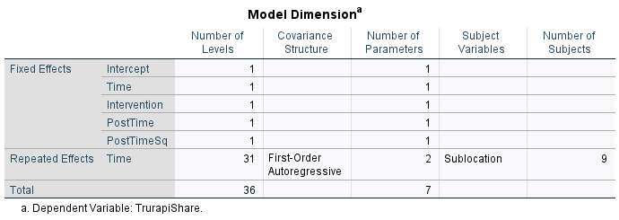

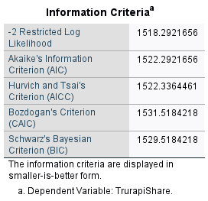
Fixed Effects
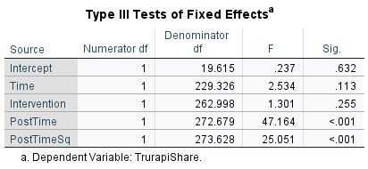
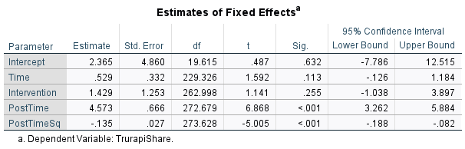

Covariance Parameters
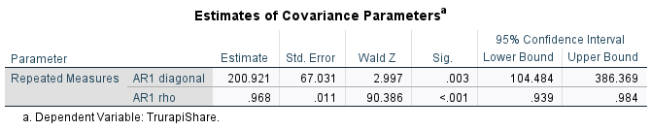

- Cartridges
Mixed Model Analysis
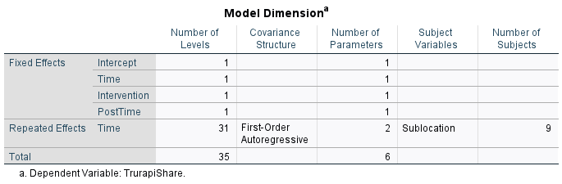
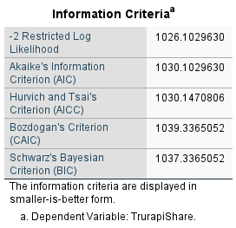
Fixed Effects
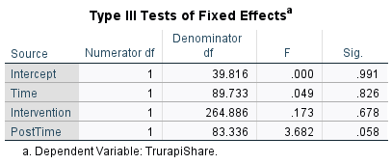
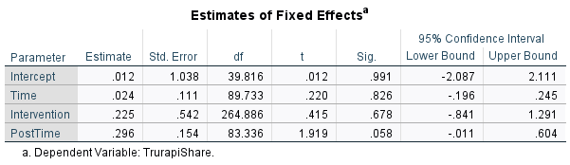

Covariance Parameters
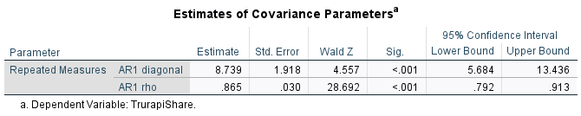

- Vials
Mixed Model Analysis
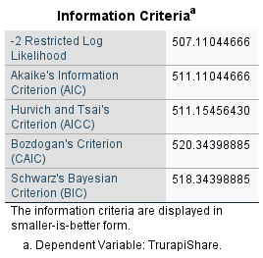
Fixed Effects
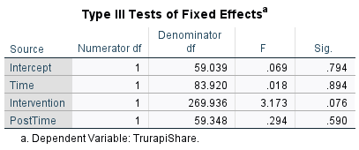
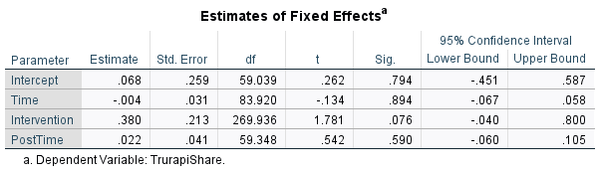

Covariance Parameters
